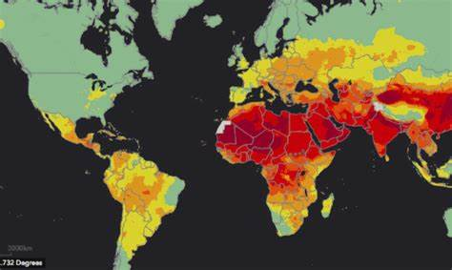

AIR QUALITY ANALYSIS

AND PREDICTION IN TAMILNADU

AIR QUALITY ANALYSIS AND PREDICTION IN TAMIL NADU

Team member

AU732521104057:VISWAKUMAR.M

PHASE 2:SUBMISSION DOCUMENT

DICT

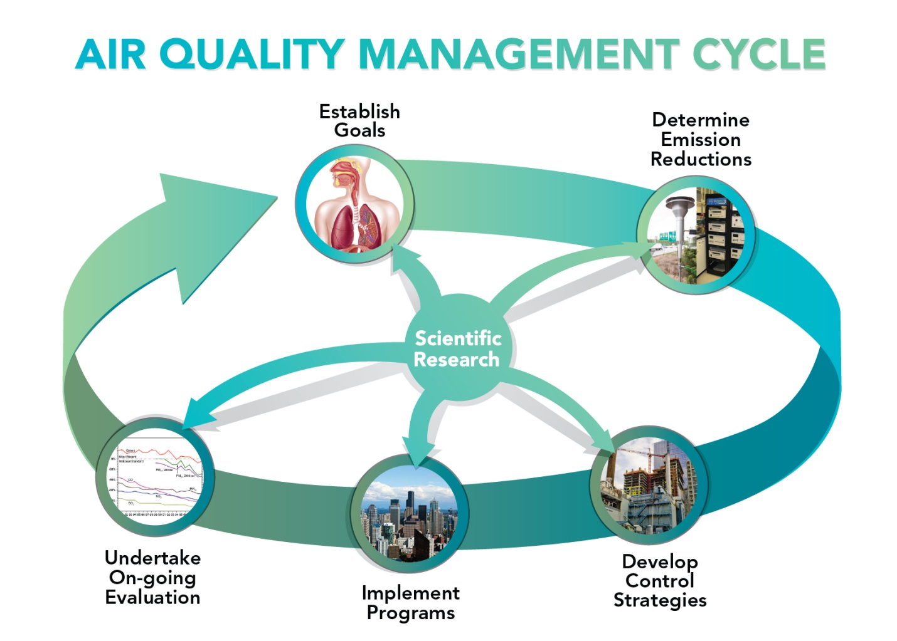

INTRODUCTION: Air quality refers to the condition or cleanliness of the air we breathe it is typical assessed based on the concentration of various pollutants and particular matter in the atmosphere.

1.Ventilation:

Ventilation is the process of exchanging indoor air with fresh outdoor air. Proper ventilation helps remove indoor pollutants, control temperature and humidity, and ensure a healthy living or working environment. There are various ventilation systems, including natural ventilation, mechanical ventilation, and hybrid systems.

2. Air Quality: Maintaining good indoor air quality is essential for health and comfort. This includes managing pollutants like dust, allergens, chemicals, and odors. Air purifiers, filters, and proper building design can help improve air quality.

3. Humidity Control: Controlling humidity levels is important for comfort and health. High humidity can lead to mold growth, while low humidity can cause discomfort and health issues. Humidifiers and dehumidifiers are used to manage indoor humidity.

4. Temperature Regulation: Maintaining a comfortable temperature is vital. Heating, ventilation, and air conditioning (HVAC) systems are used to regulate indoor temperature. Energy-efficient systems are important for cost savings and environmental concerns.

5. Air Distribution: How air is distributed within a space is crucial. Ductwork, fans, and air registers ensure that conditioned air is delivered effectively to all areas. Proper air distribution helps avoid hot or cold spots.

7. Monitoring and Control: Modern air management systems often incorporate sensors and automation for real-time monitoring and control. This helps adapt to changing conditions and optimize air quality and energy use.

8. Regulations and Standards: Building codes and regulations often mandate specific air quality and management standards to ensure occupant health and safety.

9. Maintenance: Regular maintenance of ventilation systems, filters, and other components is crucial to ensure they operate effectively and efficiently air management is important in various settings, including homes, offices, hospitals, factories, and vehicles, to create a healthy and comfortable environment while optimizing energy use. The specific requirements and technologies used can vary depending on the context.

EXLPORATORY ANALYSIS:

To begin the air exploratory analysis first import libraries and defining the air society managing things air quality restrictions are manage to develop the environmental area.

DATA SOURCE:

DATASET LINK:[**https://tn.data.gov.in/resource/location-wise-daily-ambient-air-quality-tamil-nadu-year-2014**](https://tn.data.gov.in/resource/location-wise-daily-ambient-air-quality-tamil-nadu-year-2014)

**SOURCE PROGRAM:**

**# Import necessary libraries**

**import pandas as pd**

**from sklearn.model_selection import train_test_split**

**from sklearn.linear_model import LinearRegression**

**from sklearn.metrics import mean_squared_error**

**import matplotlib.pyplot as plt**

**# Load air quality data (sample data, you'd need actual data)**

**data = pd.read_csv('air_quality_data.csv')**

**# Data preprocessing**

**# Assuming 'PM2.5' is the target variable, and other columns are features**

**X = data.drop('PM2.5', axis=1)**

**y = data['PM2.5']**

**# Split the data into training and testing sets**

**X_train, X_test, y_train, y_test = train_test_split(X, y, test_size=0.2, random_state=42)**

**# Train a simple linear regression model**

**model = LinearRegression()**

**model.fit(X_train, y_train)**

**# Make predictions**

**y_pred = model.predict(X_test)**

**# Evaluate the model**

**mse = mean_squared_error(y_test, y_pred)**

**print(f"Mean Squared Error: {mse}")**

**# Plot the actual vs. predicted values**

**plt.scatter(y_test, y_pred)**

**plt.xlabel('Actual PM2.5')**

**plt.ylabel('Predicted PM2.5')**

**plt.title('Actual vs. Predicted PM2.5')**

**plt.show()**

conclusion:

In conclusion, air quality analysis and prediction are crucial for monitoring and managing air pollution, which has significant environmental and public health implications. This process involves collecting, processing, and modeling air quality data to provide valuable insights and predictions